Implement programs to check stationarity of a time series data.
EX:No.5 DATE:01/04/25

AIM:
To Implement programs to check stationarity of a time series data.

OBJECTIVE:
To analyze whether the air pollution time-series data is stationary using statistical tests and visualizations.

BACKGROUND:
- A stationary time series has a constant mean, variance, and no seasonality.
- Stationarity is important for forecasting and modeling.
- Non-stationary data needs transformations like differencing.
- Statistical tests like ADF (Augmented Dickey-Fuller) test help detect stationarity.
- Visual methods like rolling statistics help identify trends and variance changes.

SCOPE OF THE PROGRAM:
- Load and clean air pollution time-series data.
- Check for missing values and handle them.
- Use rolling mean and standard deviation to check stationarity.
- Apply Augmented Dickey-Fuller (ADF) test for statistical confirmation.
- Apply differencing if the data is non-stationary.

CODE:
import pandas as pd
import matplotlib.pyplot as plt
import seaborn as sns

# Set style for better visuals
sns.set(style="whitegrid", palette="muted")

# Load the dataset
df = pd.read_csv('microsoft.csv', parse_dates=['Date'])
df.sort_values('Date', inplace=True)

# Quick look at the data
print(df.head())
print("\nMissing values:\n", df.isnull().sum())

# Plot stock closing price over time
plt.figure(figsize=(14, 6))
plt.plot(df['Date'], df['Close'], label='Close Price')
plt.title('Microsoft Stock Closing Price Over Time')
plt.xlabel('Date')
plt.ylabel('Price')
plt.legend()
plt.tight_layout()
plt.show()

# Calculate moving averages
df['MA20'] = df['Close'].rolling(window=20).mean()
df['MA50'] = df['Close'].rolling(window=50).mean()

# Plot with moving averages
plt.figure(figsize=(14, 6))
plt.plot(df['Date'], df['Close'], label='Close Price', alpha=0.5)
plt.plot(df['Date'], df['MA20'], label='20-Day MA', color='orange')
plt.plot(df['Date'], df['MA50'], label='50-Day MA', color='green')
plt.title('Microsoft Stock Price with Moving Averages')
plt.xlabel('Date')
plt.ylabel('Price')
plt.legend()
plt.tight_layout()
plt.show()

# Optional: Calculate and show basic trend indicators
df['Daily Return'] = df['Close'].pct_change()
print("\nSummary statistics for daily returns:")
print(df['Daily Return'].describe())

OUTPUT:
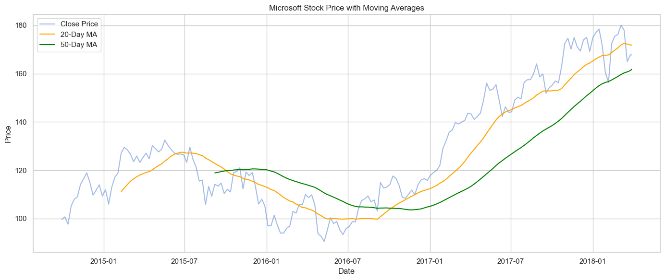

RESULT:
Thus, the program using the time series data implementation has been done successfully.

